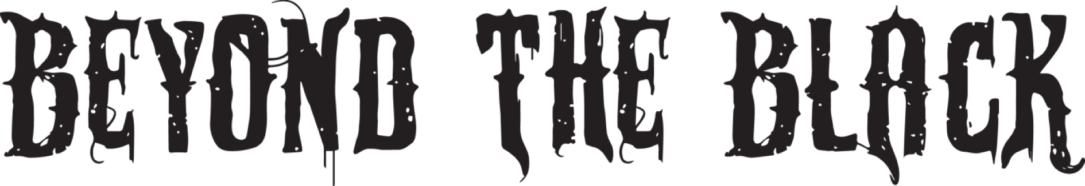

BEYOND THE BLACK Releases New Single and Lyric Video for “Golden Pariahs”
New Album Hørizøns To Be Released On June 19th!
On Co-Headline Tour With Amaranthe This Winter 2020!
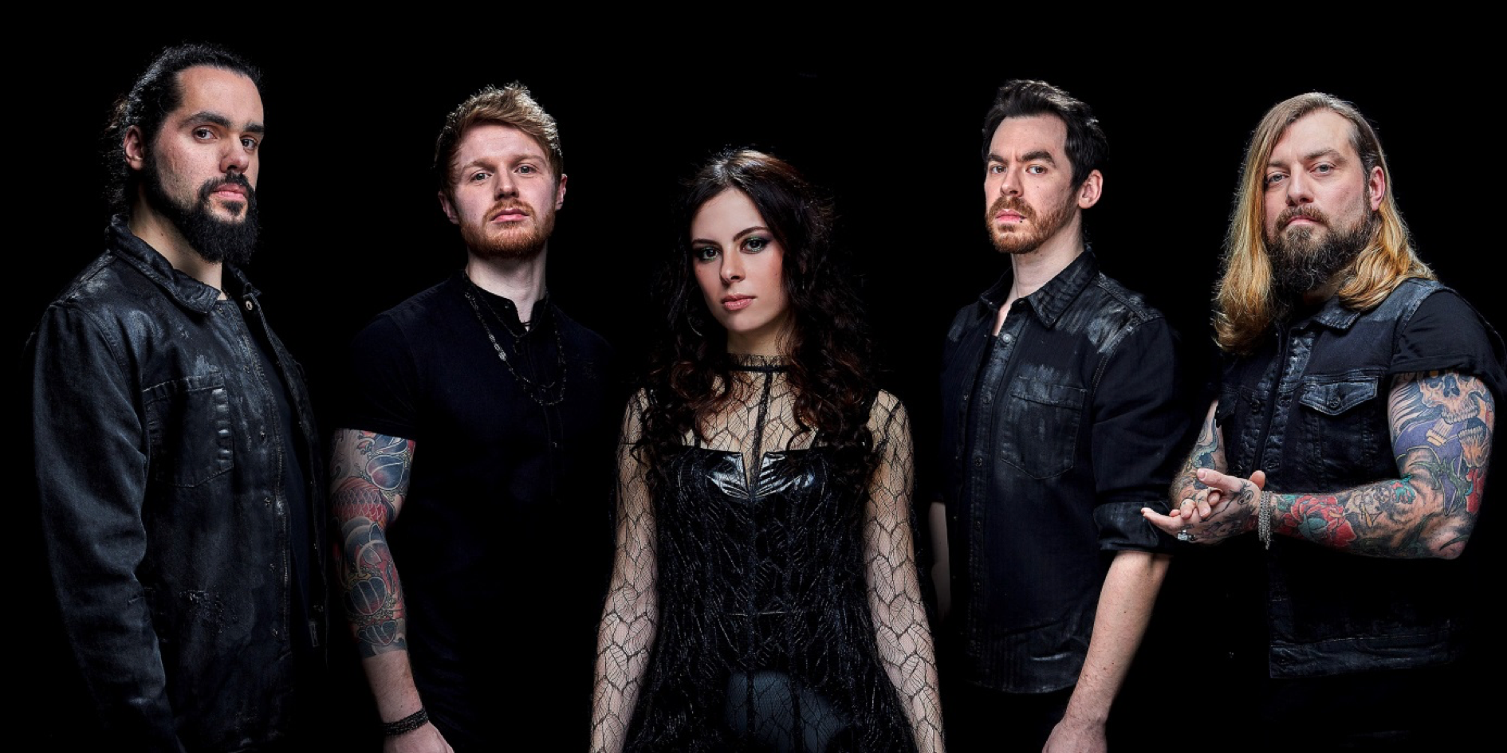
Pre-Order Hørizøns HERE | Watch The New Video NOW
[Photo Credit: Chris Heinrich]
Hørizøns ascends to an energetic, spell-binding melodic manifesto!
Today symphonic metal outfit BEYOND THE BLACK presents their new single, “Golden Pariahs”, off their upcoming album, Hørizøns, to be released via Napalm Records on June 19th , 2020.
An echoing symbiosis of brutal drums and major electronic influences inflames the quintessence of “Golden Pariahs”: Their new epos explodes in an intoxicating fusion of Jennifer Haben’s striking, exceptional vocals, highly-clocked drums and another facet of the quintet’s multifarious spectra. BEYOND THE BLACK rises with sonorous, energetic severity and bittersweet elements. The vigorous soundscape is coupled with the song’s strong message and sets the characteristic sign to fight, even in dark times. BEYOND THE BLACK prove their versatile musical identity once again and that the modern blend of melodic rock and metal is flowing through their veins.

“Golden Pariahs” is a high voltage stunner and a melodic hymn for all the erroneously underdogs to defeat their inner demons. Pull us under, hear the thunder!

Watch the new lyric video for „Golden Pariahs“ HERE:
[thumbnail]

Jennifer Haben on the new album:
“With 2019 having been the biggest year in our career as a band so far, we were thrilled and anxious to get back to the studio and start writing again – not just to make up to the fast and amazing development that has happened in the band since our last album, but to pin this development down also musically for everyone to hear and see. Hørizøns is unmistakably a BEYOND THE BLACK album, but with so many new facets and personality adding up to the classic BEYOND THE BLACK ID that make it a true band-album. For us this has definitely been a walk on the tightrope and we feel to have it accomplished to its fullest. Without beating around the bush, we can say that we're extremely proud and confident that Hørizøns is the best BEYOND THE BLACK album to date.“

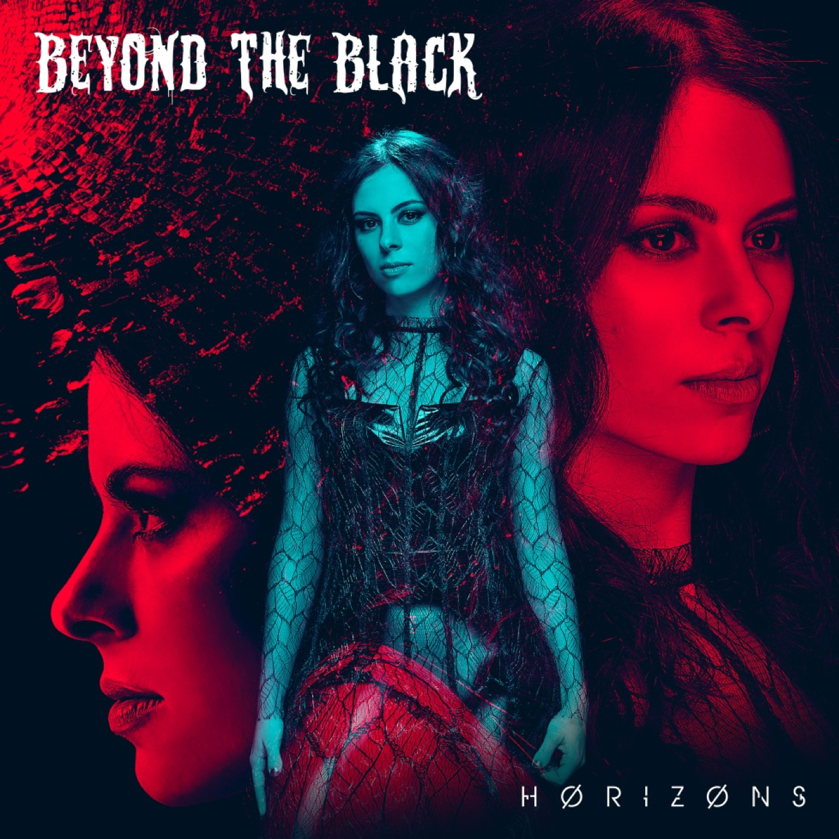
Pre-Order Hørizøns NOW:
The female fronted quintet unbolts their unequalled, differentiated spectra of symphonic and melodic rock spiced with sonorous melodious metal soundscapes in 13 manifold songs. The album kicks off with its heavy, yet atmospheric title track, spanning the range of intumescent soundscapes and Jennifer Haben’s crystal clear, striking vocals. Beautiful yet strong harmonies, emotional storytelling and powerful vocal lines weave throughout “Wounded Healer” (feat. Elize Rhyde off Amaranthe) and will light your way in gloomy times. Dark subliminal grooves coalesce with harmonizing guitar lines and form the prevailing nexus of “Human” and it’s unmistakably catchy chorus. Another facet rises with “You Are Not Alone”, which is dominated by electronic influences as well as symphonic sounding violins. Hørizøns’ atmospherically dark harshness creates the stylistic bow over the distinctive melodic rock meets pop sound in symbiosis with fragile yet strong fragments. The charismatic outfit persuades with a rousing, emotional clout and their strong, confident message off self-assertion.
Tracklisting:
- Horizons
- Misery
- Wounded Healer (feat. Elize Ryd)
- Some Kind Of Monster
- Human
- Golden Pariahs
- Marching On
- You're Not Alone
- Out Of The Ashes
- Paralyzed
- Coming Home
- I Won't Surrender (Feat. Tina Guo)
- Welcome To My Wasteland

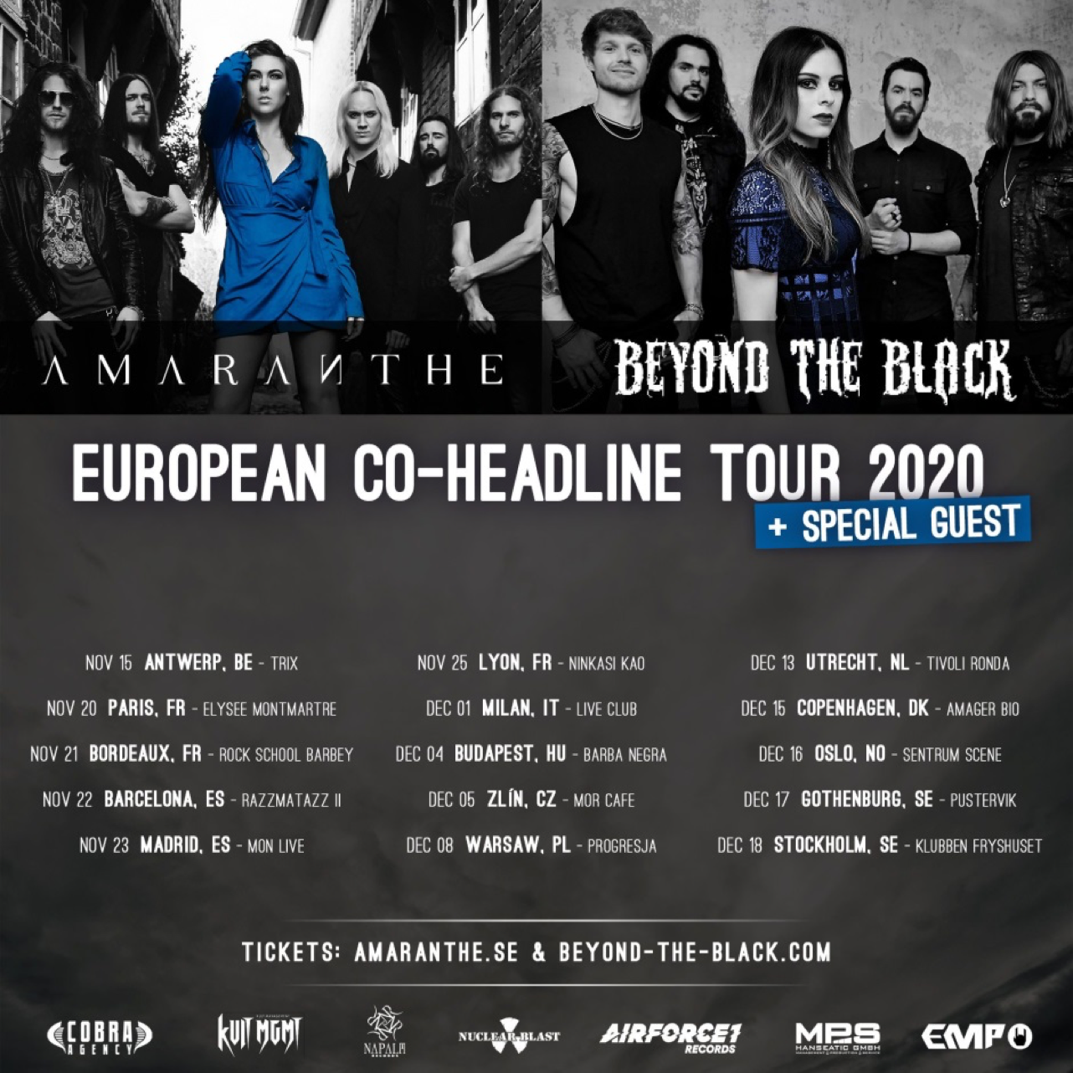
Catch BEYOND THE BLACK live:
This autumn will get thrilling: BEYOND THE BLACK joins forces with modern melodic metal standouts Amaranthe to kick off their joint co-headline tour, to spread the news of a new metal generation across the continent.

13.11.20 DE – Munich / Zenith
14.11.20 DE – Oberhausen / Turbinenhalle I
15.11.20 BE – Antwerp Trix
20.11.20 FR – Paris / Elysée Montmartre
21.11.20 FR – Bordeaux / Rock School Barbey
22.11.20 ES – Barcelona / Razzmatazz II
23.11.20 ES – Madrid / Mon Live
25.11.20 FR – Lyon / Ninkasi Kao
26.11.20 DE – Ludwigsburg / MHP Arena
27.11.20 DE – Offenbach / Stadthalle
28.11.20 DE – Leipzig / Haus Auensee
30.11.20 CH – Zurich / Komplex 457
01.12.20 IT – Milan / Live Club
02.12.20 CH – Lausanne / Metropole
04.12.20 HU – Budapest / Barba Negra
05.12.20 CZ – Zlín / MOR Café
07.12.20 AT – Vienna / Arena
08.12.20 PL – Warsaw / Progresja
09.12.20 DE – Berlin / Columbiahalle
11.12.20 DE – Geiselwind / Event Hall
12.12.20 DE – Hamburg / Sporthalle
13.12.20 NL – Utrecht / Trivoli Ronda
15.12.20 DK – Copenhagen / Amager Bio
16.12.20 NO – Oslo / Sentrum Scene
17.12.20 SE – Gothenburg / Pustervik
18.12.20 SE – Stockholm / Klubben Fryshuset

BEYOND THE BLACK are:
Jennifer Haben (Vocals)
Stefan Herkenhoff (Bass)
Chris Hermsdörfer (Guit./Backings)
Tobi Lodes (Guit./Backings)
Kai Tschierschky (Drums)
Find BEYOND THE BLACK online:
FACEBOOK
INSTAGRAM
NAPALM RECORDS

